

Mexican Emigration to the US: last two decades

Introduction to Programming in Python

Professor Jeffrey Levy

Andres Chaparro Altamirano

ID: 12215739

University of Chicago Harris School of Public Policy

Introduction

The past few decades have seen booms and busts of Mexican and South American immigration to the United States. This has been a contentiuous issue in both countries and has recently resurfaced as a key topic in the diplomatic and commercial relations between these two countries. The purpose of this analysis is to go through some of the common assumption about Mexican immigration and to try to take a look at some of the factors that may be affecting it.

The analysis will take a look at the changes in immigration since 1994, a seminal year in US-Mexico relations due to the signing of the NAFTA accords. We will compare some key macroeconomic variables and try to see if they are useful in understanding the changes in South to North migration.

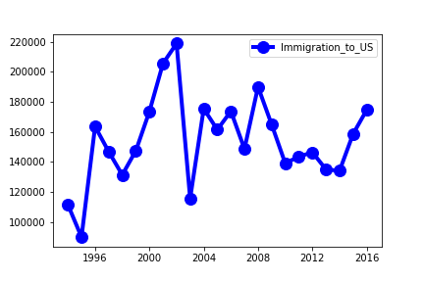

Methodology

Basically there are two common assumptions about immigration. One is why I’m calling the Economic model, and the other the Social model. The Economic model, propagated by relevant policymakers on both sides of the border including the Mexican president[1] argues that there is a problem of lack of opportunities in Mexico and low economic growth. And that by addressing those issues immigration will return to low and acceptable levels. The notion that the NAFTA failed to treat the underlying problems in the Mexican economy and failed to provide opportunities for Mexican laborers while opening them up to more competition has, according to this model, damaged certain regions in Mexico where the laborers see no other solution but to go to the US in search for better opportunities.

For the economic model we are using both the growht in US and Mexican GDP per capita. By analyzing these data we can try to understand if there is any clear elasticity in the decision to migrate relative to opportunities. We would expect that when Mexico is doing well compared to the US, immigration to the latter country would diminish, and the opposite.

In this analysis we will find our first problem. As we can see on the graph below, US and MX GDP per capita growth seems to oscilate in the same distance between these two countries. It is true that the Mexican per capita GDP growth is more volatile, but they are not different enough to be able to distinguish between them. For this reason we are just going to focus on absolute terms on the decrease or improvement of the Mexican GDP. From an economical standpoint this may have some explanations: 1) a lack of growth in Mexico vs US can have very different consequences to the standard of living of an average person, 2) there may be some myopia as to what is happening elsewhere and people make decisions mostly on what is happening in their country and 3) people have a lower threshold as to what is an acceptable quality of living, and below that point they will attempt to emigrate to the US without taking into account the current expected value of going.

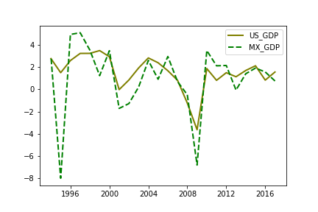

The second model we are looking at, or what I call the Social model is less about economic opportunity and more about other issues in standard of living. The main issue for many people in Mexico over the last few decades has been insecurity. For this model we are using a variable for Intentional Homicides per 100,000 people. The idea is to see if there is any relation between worsening security conditions and increased immigration.

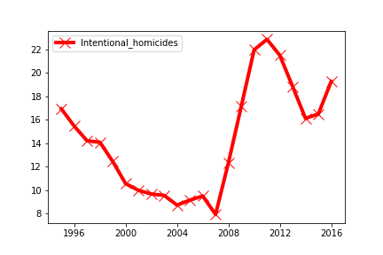

Results and Conclusions

Of the two models we used, the one that was statistically significant was the Social Model. It seems like there is a strong relation between homicide rates and immigration. We couldn’t find any relationship statistically significant between economic performance and immigration rates.



I would like to add two comments to these results. 1) we need to be careful because in the middle of our data we have the big economic depression of 2008 that has worldwide implications. Another study could try to untangle the effect of these variables while considering more carefully the implications of this depression. The second issue is that the effects of immigration can change considerably, as well as the magnitude and the main relationships between these variables. In the 90s it looks like economic factors weighted more on people than the still lower levels of homicides. After 2008 the opposite seems to true. Even as both countries have rebounded economically, Mexico has strong rates of migration (if overall decreasing) to the US.

The following graphs, if a little funky, helps to clearly explain my earlier point. There seems to be three clear periods of Mexican migration to the US almost coinciding to the 90s, 00s, and 10s decades. Further study of this topic could focus on one period, or to try every period individually, each with its appropriate social and economic context, and with their own regressions and models.

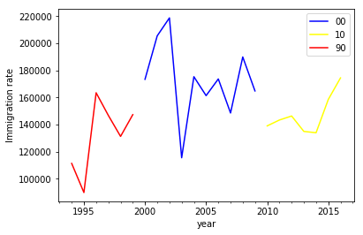

References

The databases used in this paper are included in the code part of the assignment and come from the World Bank group and the Organization for Economic Cooperation and Development.

The article mentioned in a footnote can be found here <https://www.elfinanciero.com.mx/nacional/para-resolver-migracion-hay-que-atender-las-causas-insiste-amlo>

1. Para resolver migración hay que atender las causas, insiste AMLO – El Financiero